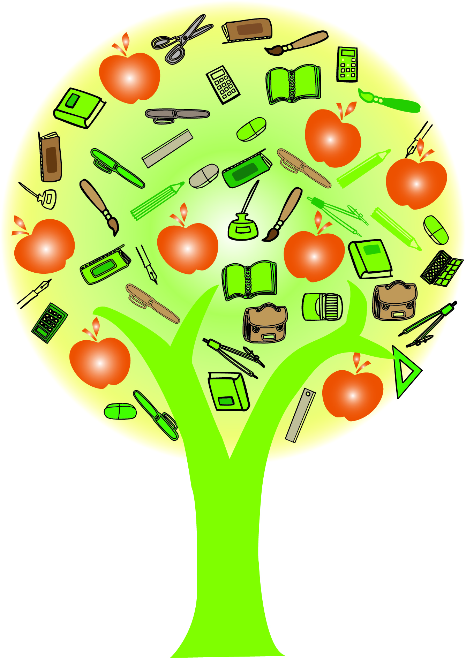**FCOE ELA CCSS Lesson Template**

|  |  |  |
| --- | --- | --- |
| Lesson Author: | Grade Level: | Subject: |
| Unit Theme: *EQ-What universal idea/ideal ties this lesson to other lessons in the unit?* | Lesson Title/Topic: *EQ-What title/topic would this lesson be given in real-world or college/career applications?* | |
|  |  | |
| Grade Level Standard(s): | | |
| Lesson Objectives: *EQ-What are the content and language objectives of the lesson?* | Essential Questions: *EQ-What essential question do you want students to be able to answer by the end of the lesson(s)?* | |
|  |  | |
| Materials: | | |
| Technology Skills (Teacher): *EQ-How is technology incorporated as an avenue for your teaching?* | Technology Skills (Student): *EQ-How is technology being used by students for learning or assessment?* | |
|  |  | |
| Teaching Steps/Strategies: *EQ-Which strategies/skills can be incorporated into the lesson steps? What strategies can be used to support differentiation for ELs and other learners?* | Cross-Curricular Connections: *EQ-What skills could/should be used by students in other disciplines? What themes are connected in history, science, VAPA, mathematics, etc.?* | |
| Step 1  Step 2  Step 3  Step 4 |  | |
| 21st C Skills | | |
| Critical Thinking: *EQ-Where do my questions fall on the DOK chart? What opportunities do students have to question/think using HOTs?* | Collaboration: *EQ-How are students purposefully working in pairs, small groups, larger groups to accomplish the task?* | |
|  |  | |
| Communication: *EQ-How will students demonstrate their knowledge through listening, speaking, reading, and writing?* | Creativity: *EQ-What opportunities for creating unique and useful products will students have?* | |
|  |  | |
| Student Product: *EQ-What product(s) will students research, design, create, and present?* | | |
|  | | |
| Rigor and Relevance (note: there are skills practiced in each quadrant, but aim for Quadrant D) | | |
| Quad C (High Rigor/Low Relevance) | Quad D (High Rigor/High Relevance) | |
| Quad A (Low Rigor/Low Relevance) | Quad B (Low Rigor/ High Relevance) | |
| Assessment and Rubrics: *EQ-How will learning be assessed within the context of the lesson both formatively and summatively? What will students produce or create as a product of their learning? What rubric will I have shared with students prior to the assessment?* | | |
|  | | |