**How to Locate Data in DataQuest**

1. Visit this website: <http://data1.cde.ca.gov/dataquest/>

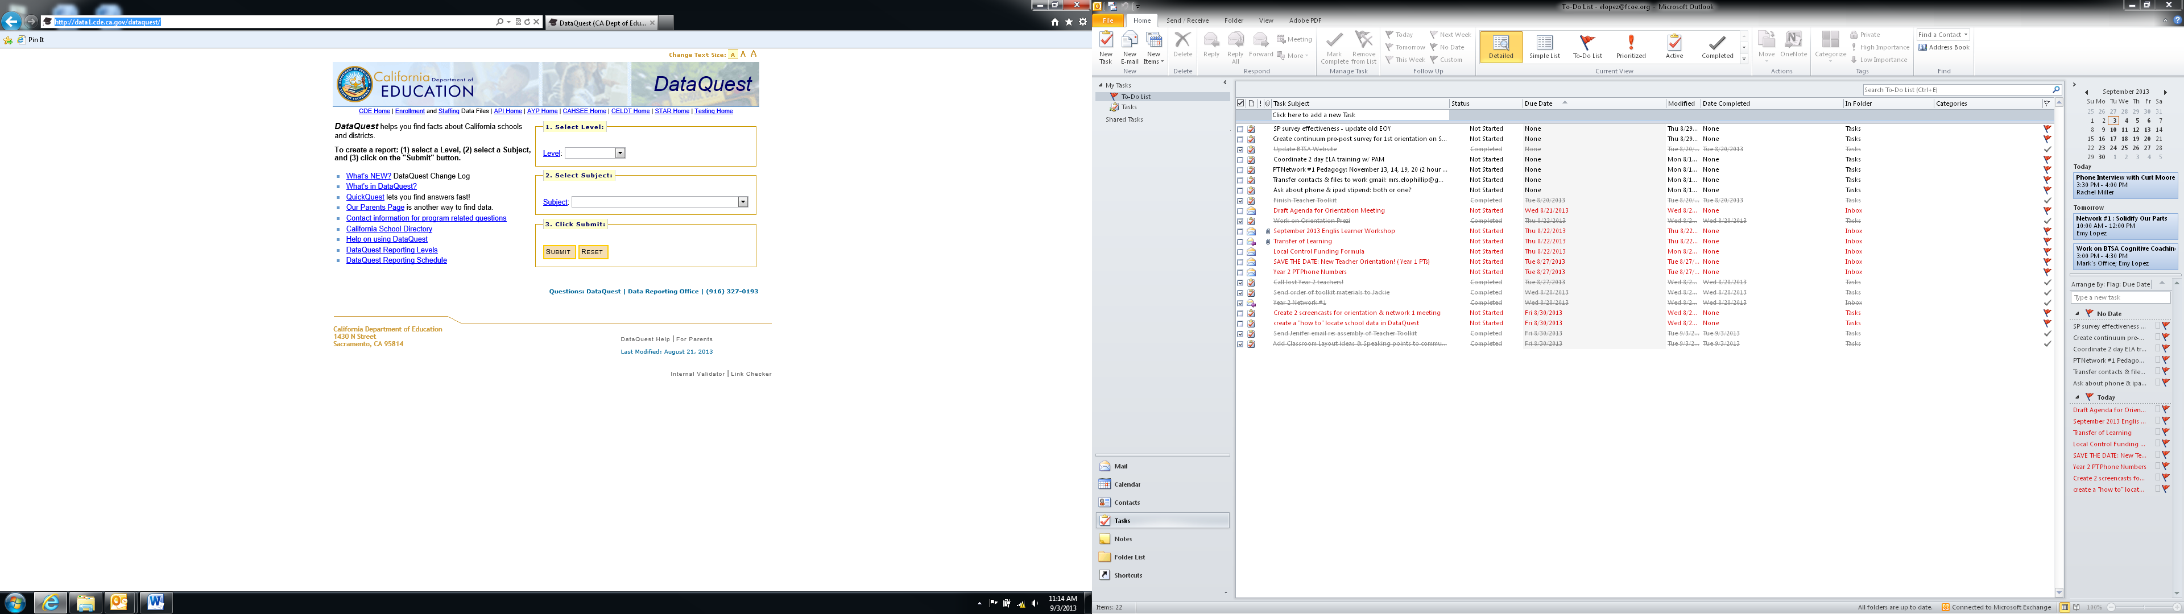

2. Click on the “Level” dropdown menu and click on “School”

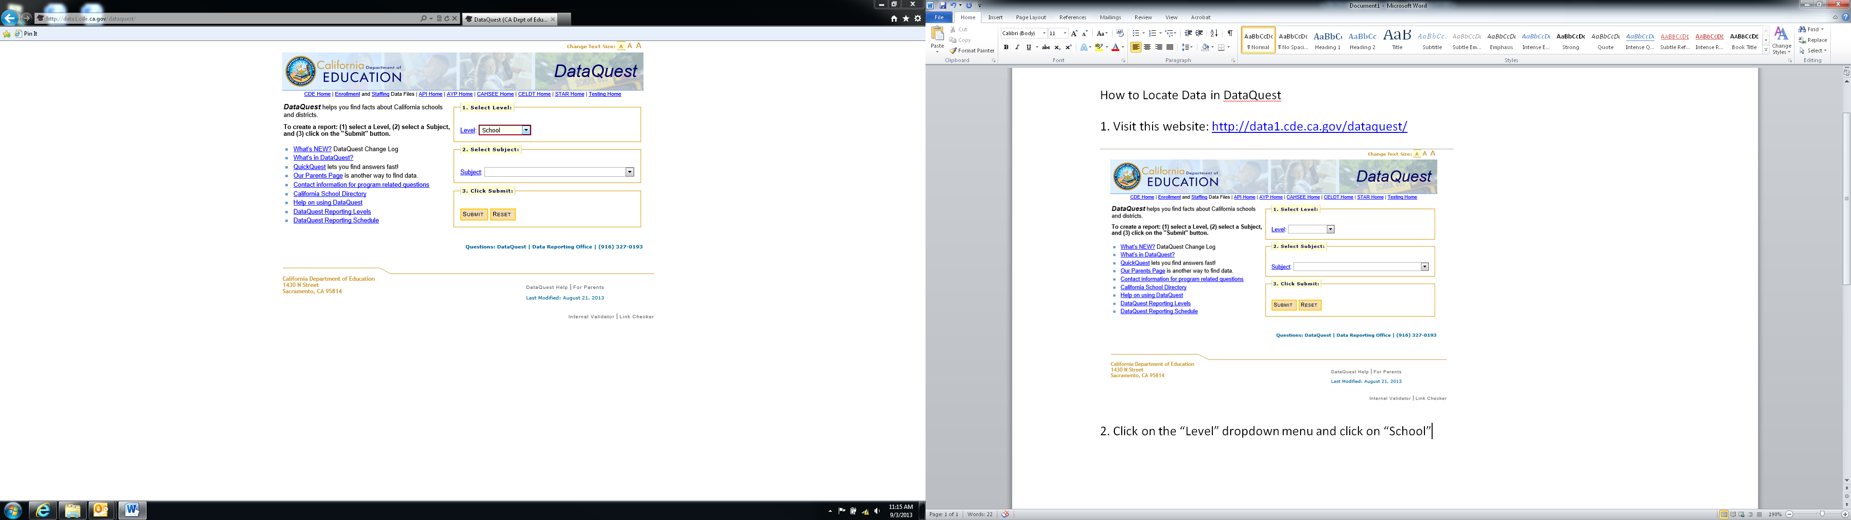

3. Click on the “Subject” dropdown menu and scroll down to the “Test Scores” section, then click on STAR Test Results. Click Submit.

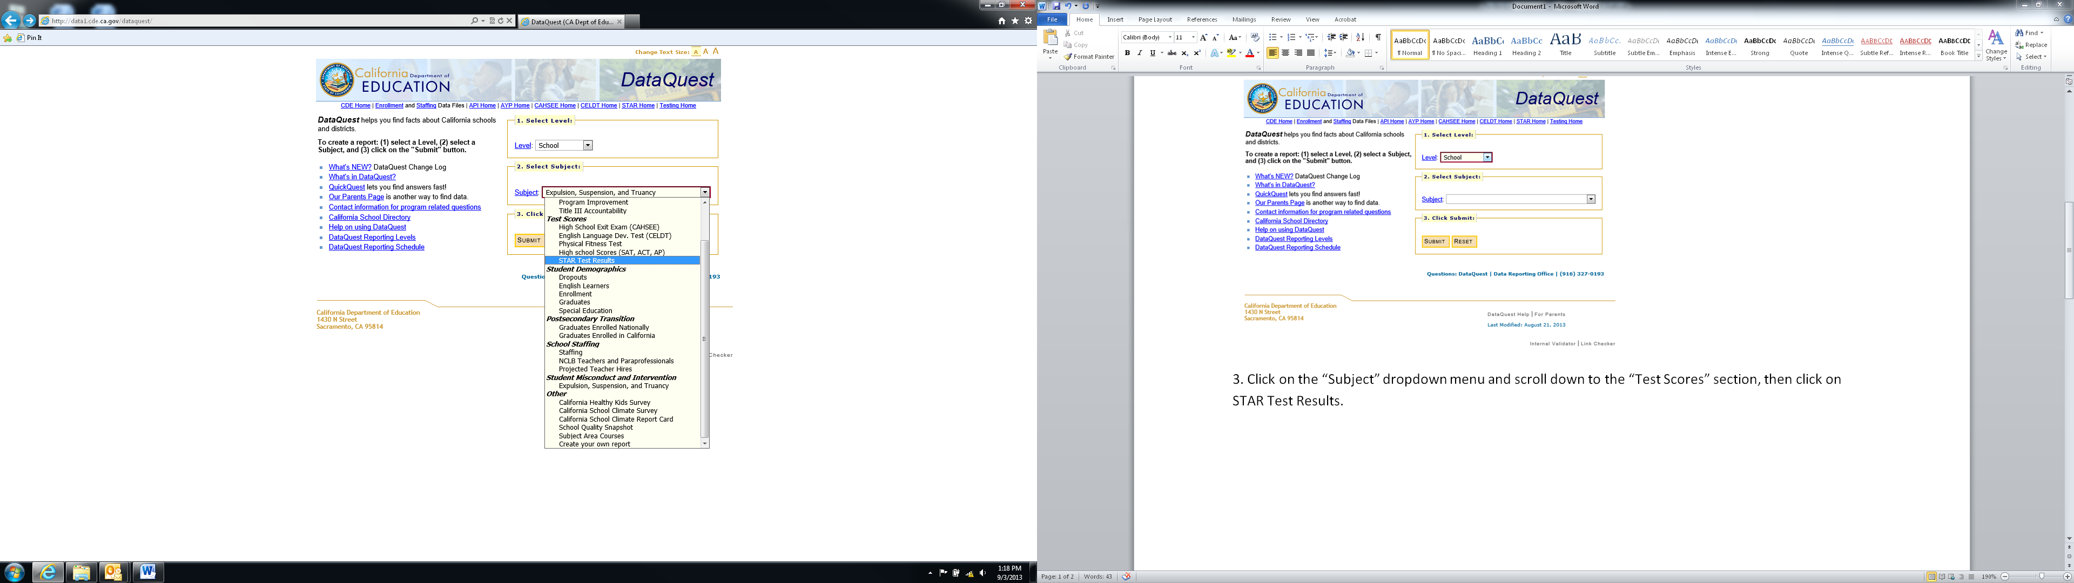

4. Type name of school site in section 2).

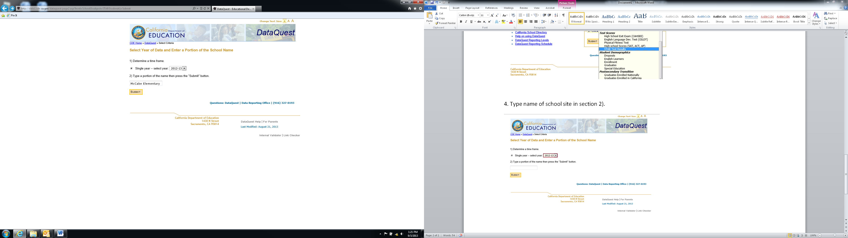

5. After selecting the appropriate school site, click “Submit”

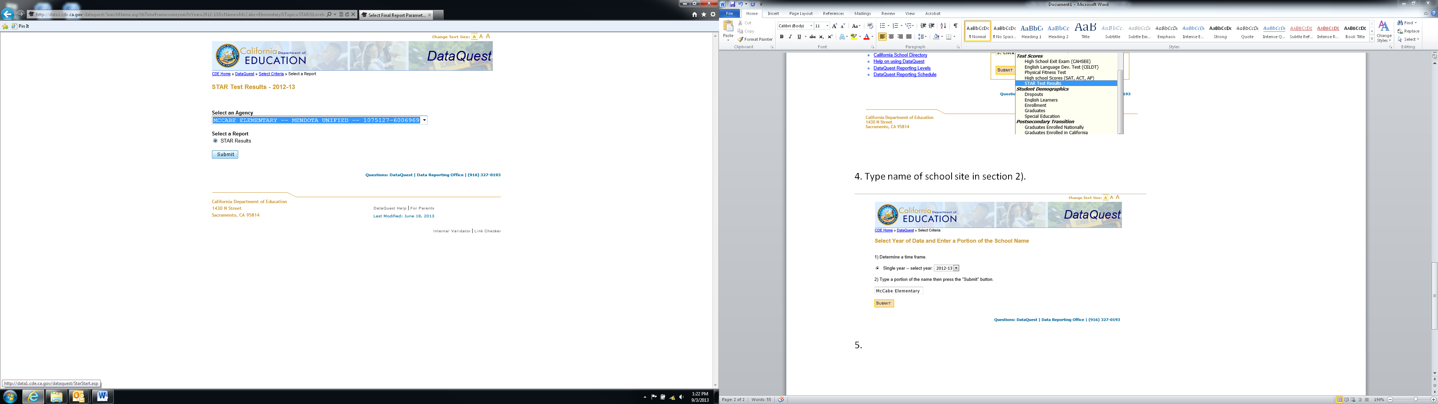

6. Click “View Report”

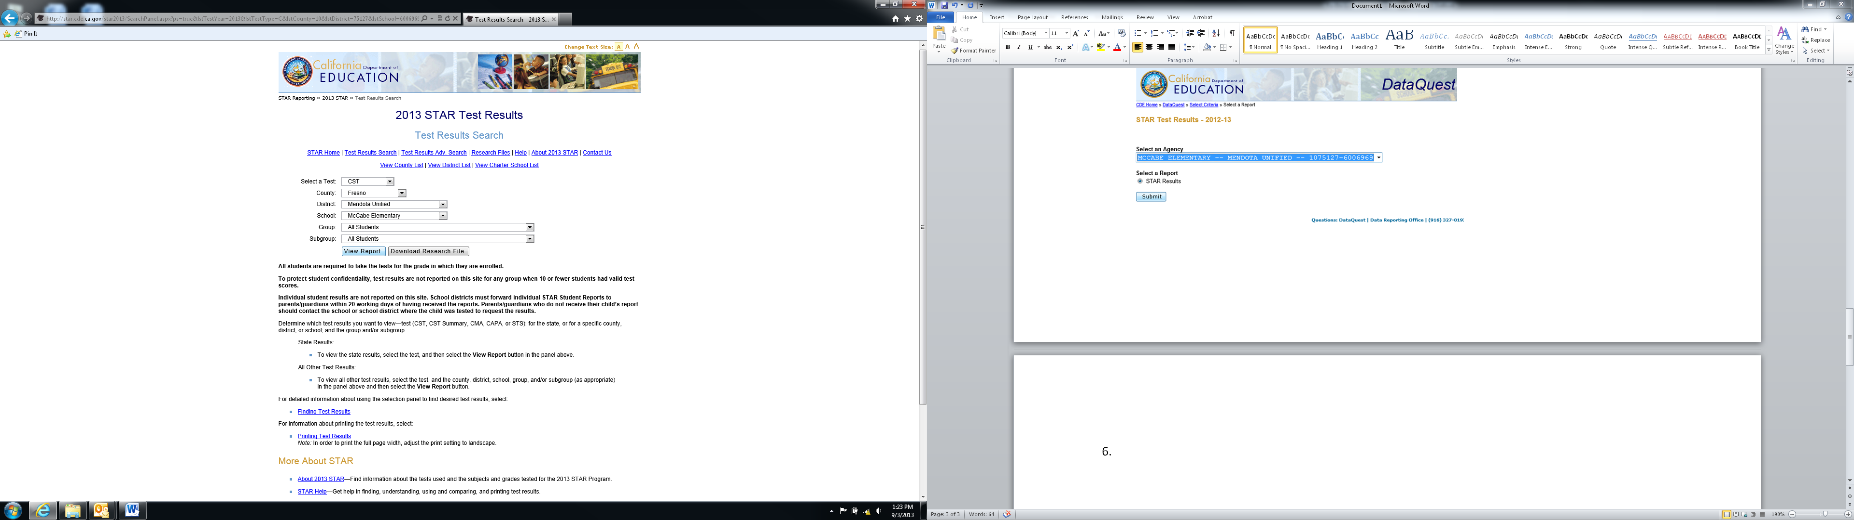

7. The most current STAR Test Results is now viewable and this report can be printed.

