**How to locate the “School Quality Snapshot” in DataQuest**

1. Visit this website: <http://data1.cde.ca.gov/dataquest/>

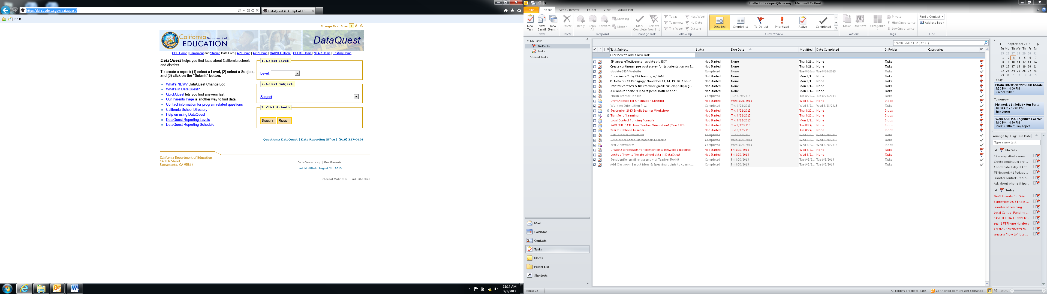

2. Click on the “Level” dropdown menu and click on “School”

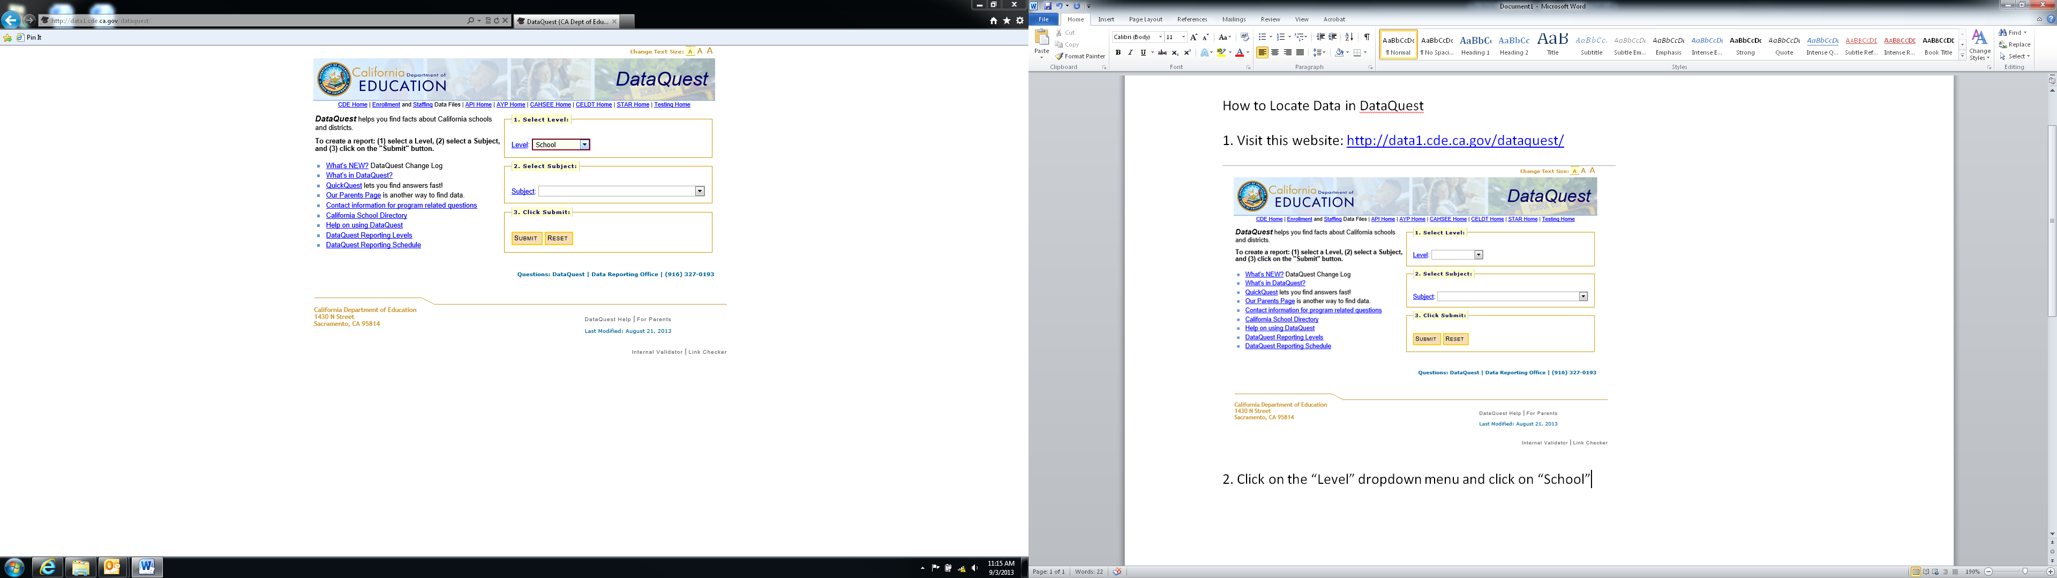

3. Click on the “Subject” dropdown menu and scroll down to the “School Quality Snapshot” option, then click to Submit.

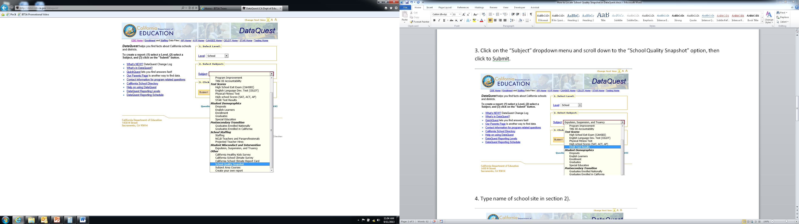

4. Enter part of school name in the text box, then click Search.

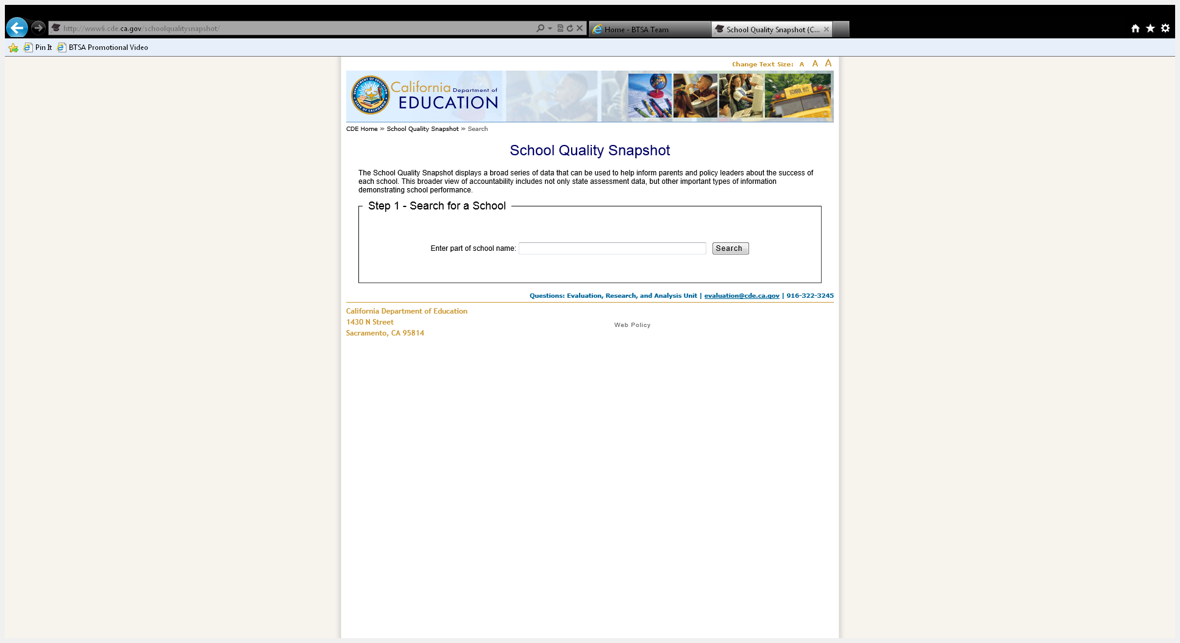

5. After selecting the appropriate school site, click Generate Report.

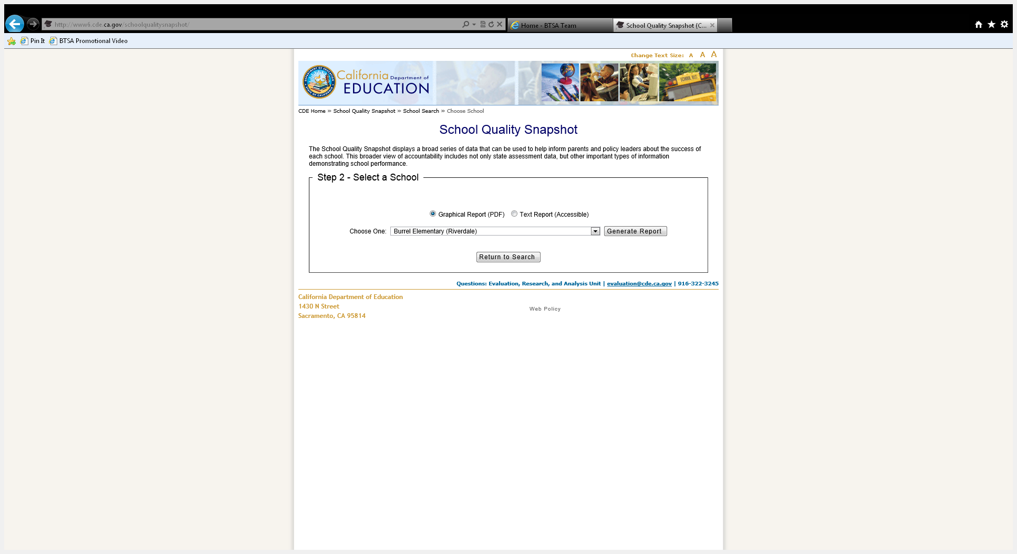

6. You may now PRINT and/or SAVE the report that appears. To SAVE the report, you will need to select PRINT and then change the printer option to ADOBE PDF. This will then allow you to save the document as a PDF file.

