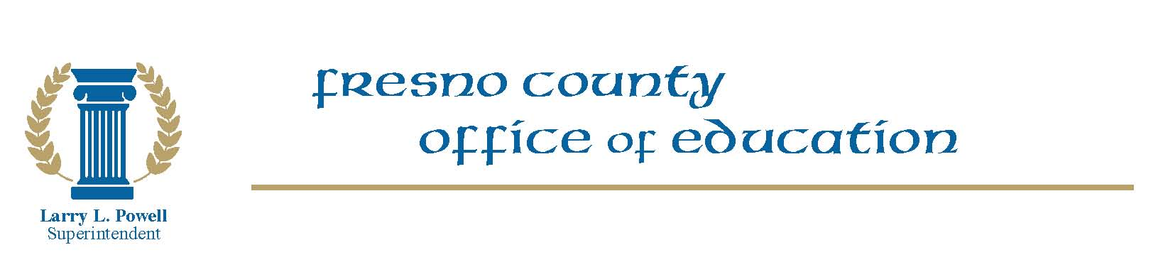

PUBLIC NOTICE

Public Hearing on the Classified and Certificated Bargaining Units’ Initial Proposals to the County Superintendent for the 2012-13 School Year

NOTICE IS HEREBY GIVEN that prior to across the table negotiations, the Classified and Certificated Bargaining Units’ Initial Proposals to the County Superintendent for the 2012-13 School Year shall be introduced at the August 16, 2012 meeting of the Fresno County Board of Education, followed by a reasonable period of “sunshining,” as required by Government Code section 3547(b). A public hearing will immediately follow.

This Public Hearing will take place at the Fresno County Office of Education, Board Room 301, located at 1111 Van Ness Avenue, Fresno, CA 93721 on Thursday, August 16, 2012, and will commence no earlier than 2:45 p.m., or as close to the time as the business of the County Board permits.

RAM/est
8/8/12

